**Practical – 2**

**Question – 2**

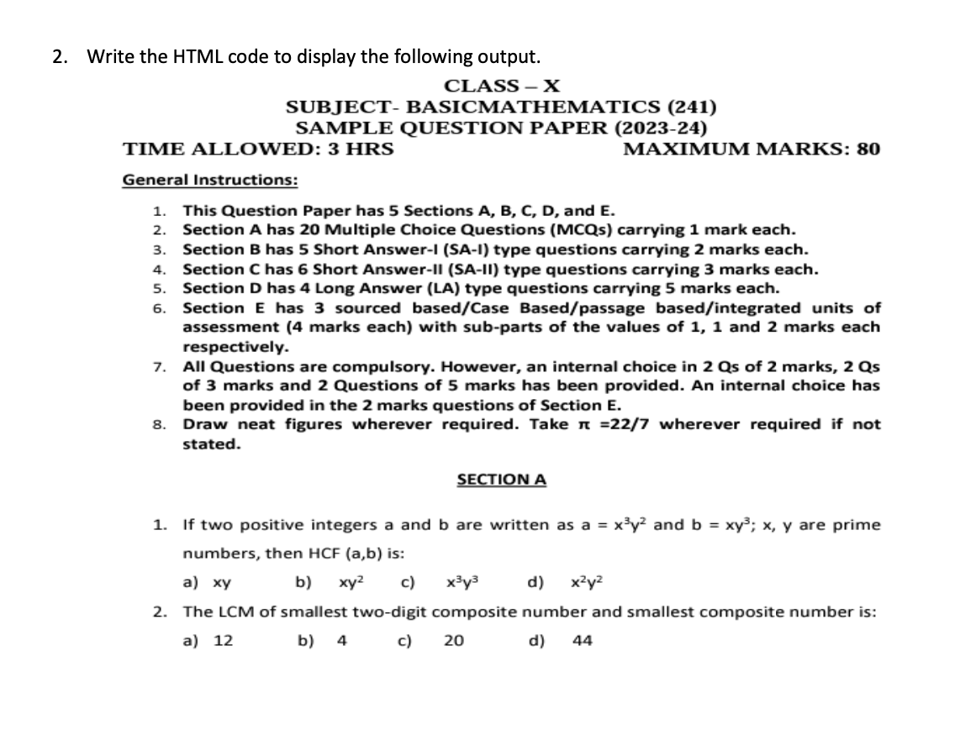

**HTML Code**

<!-- Html to print demo question paper -->

<!DOCTYPE html>

<html lang="en">

<head>

<meta charset="UTF-8">

<meta name="viewport" content="width=device-width, initial-scale=1.0">

<title>Demo Question Paper</title>

</head>

<body>

<center>

<h3>Class-X<br>

SUBJECT-BASICMATHEMATICS(241) <br>

SAMPLE QUESTION PAPER(2023-2024)</h3>

</center>

<h3 style="text-align-last : right">MAXIMUM MARKS : 80</h3>

<h3 style="text-align-last : left">TIME ALLOWED : 3 HRS</h3>

<br>

<b><u>General Instructions :</u></b><br>

1. <b>This Question Paper Has 5 Sections A,B,C,D and E.</b><br>

2. <b>Section A has 20 Multiple Choise Questions(MCQ) Carrying 1 Mark Each.</b><br>

3. <b>Section B has 5 short answers-l (SA-1) type questions carying 2 marks each.</b><br>

4. <b>Section C has 6 short answers-ll (SA-ll) type questions carrying 3 marks each.</b><br>

5. <b>Section D has 4 long answers (LA) type questions carrying 5 marks each.</b><br>

6. <b>Section E has 3 sourced based/case based/ passed based/integrated units of assessment (4 marks each) with sub-parts of the values of 1,1 and 2 marks each respectively.</b><br>

7. <b>All questions are compulsory. However, an internal choise in 2 Qs of 2 marks, 2 Qs of 3 marks and 2 questions

of 5 marks has been provided. An internal choise has been provided in the 2 marks question of Section E.</b><br>

8. <b>Draw neat figures wherever required. Take &pi;=22/7 wherever required if not stated.</b><br>

<center>

<h4><u>SECTION A</u></h4>

</center>

<p>

1. If two positive integers a and b are written as a= x<sup>3</sup>y<sup>2</sup> and b=xy<sup>3</sup>; x,y are

prime numbers, then HCF(a,b) is :

<pre>

a) xy b)xy<sup>2</sup> c)x<sup>3</sup>y<sup>3</sup> d)x<sup>2</sup>y<sup>2</sup>

</pre>

</p>

<p>

2. The LCM of smallest two-digit composite number and smallest composite number is:

<pre>

a) 12 b) 4 c) 20 d) 44

</pre>

</p>

</body>

</html>

**Output**

